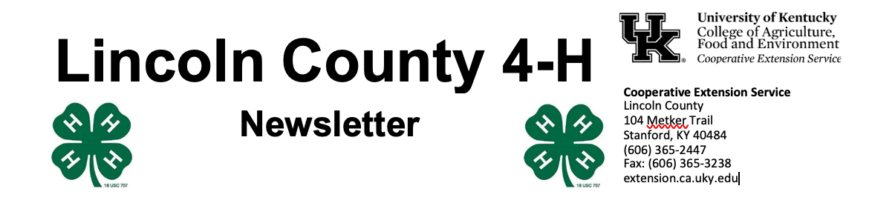
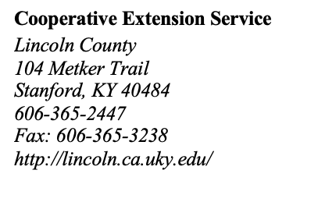
October 2022

4 - H Y O U T H D E V E L O P M E N T N E W S L E T T E R

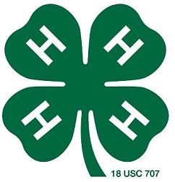

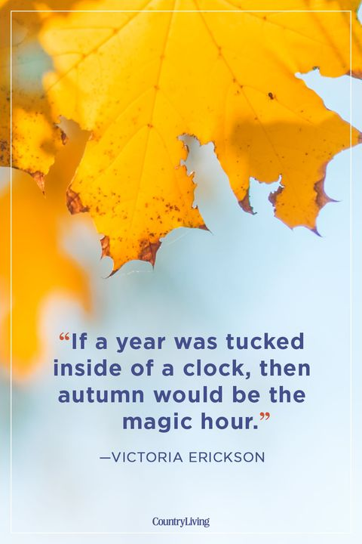

It’s officially fall and one of our favorite times of year! We are gearing up for another 4-H Achievement Banquet and hope you will join us at the Lincoln County Fairgrounds on October 20 at 6 pm.
This October we are showing FREE spooky movies at Crab Orchard City Park every Friday at 7:30 pm. Grab a chair and snacks (we’ll have a few things for sell) and bring the whole family.
Our Shooting Sports Club will be taking a brief hiatus and should resume some time in November. Please make sure you are enrolled in 4-H for this year so that you don’t miss the postcard.
We’re doing a small experiment: if you’ve read this far, please email Dani your favorite animal and tell us why it’s your favorite, and we’ll mail you a prize! danijo@uky.edu
Our office is open Monday – Friday from 8 am – 4:30 pm and closed for lunch from 12- 1 pm. Please visit www.lincoln4h.org to check out all the most recent 4-H information.

Use your phone’s camera to enroll:


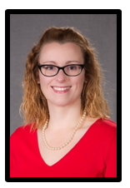
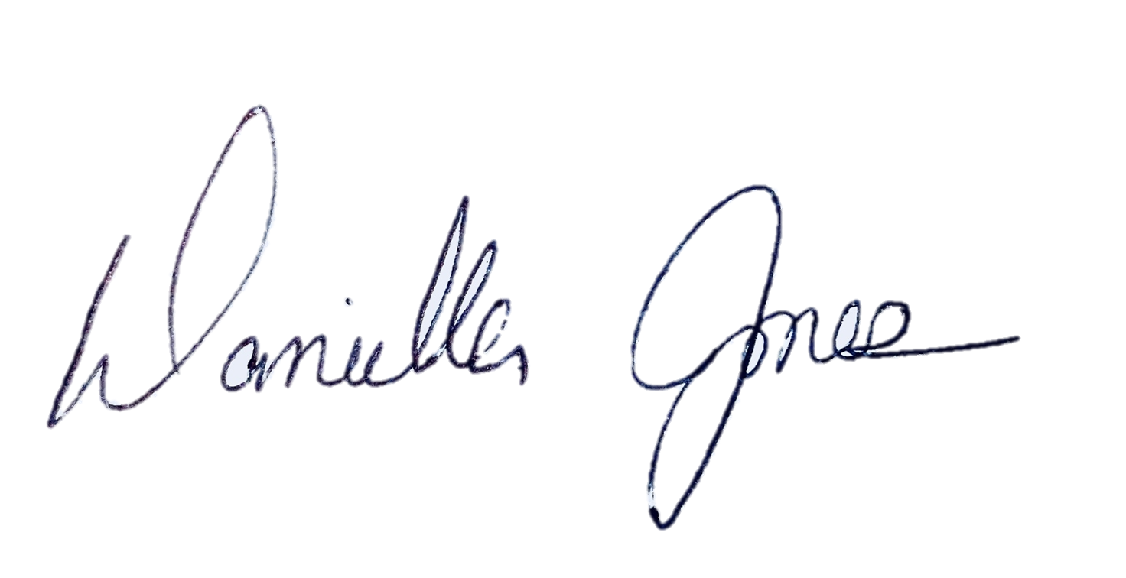
Dani Jones
Extension Program Assistant
606-365-2447
danijo@uky.edu

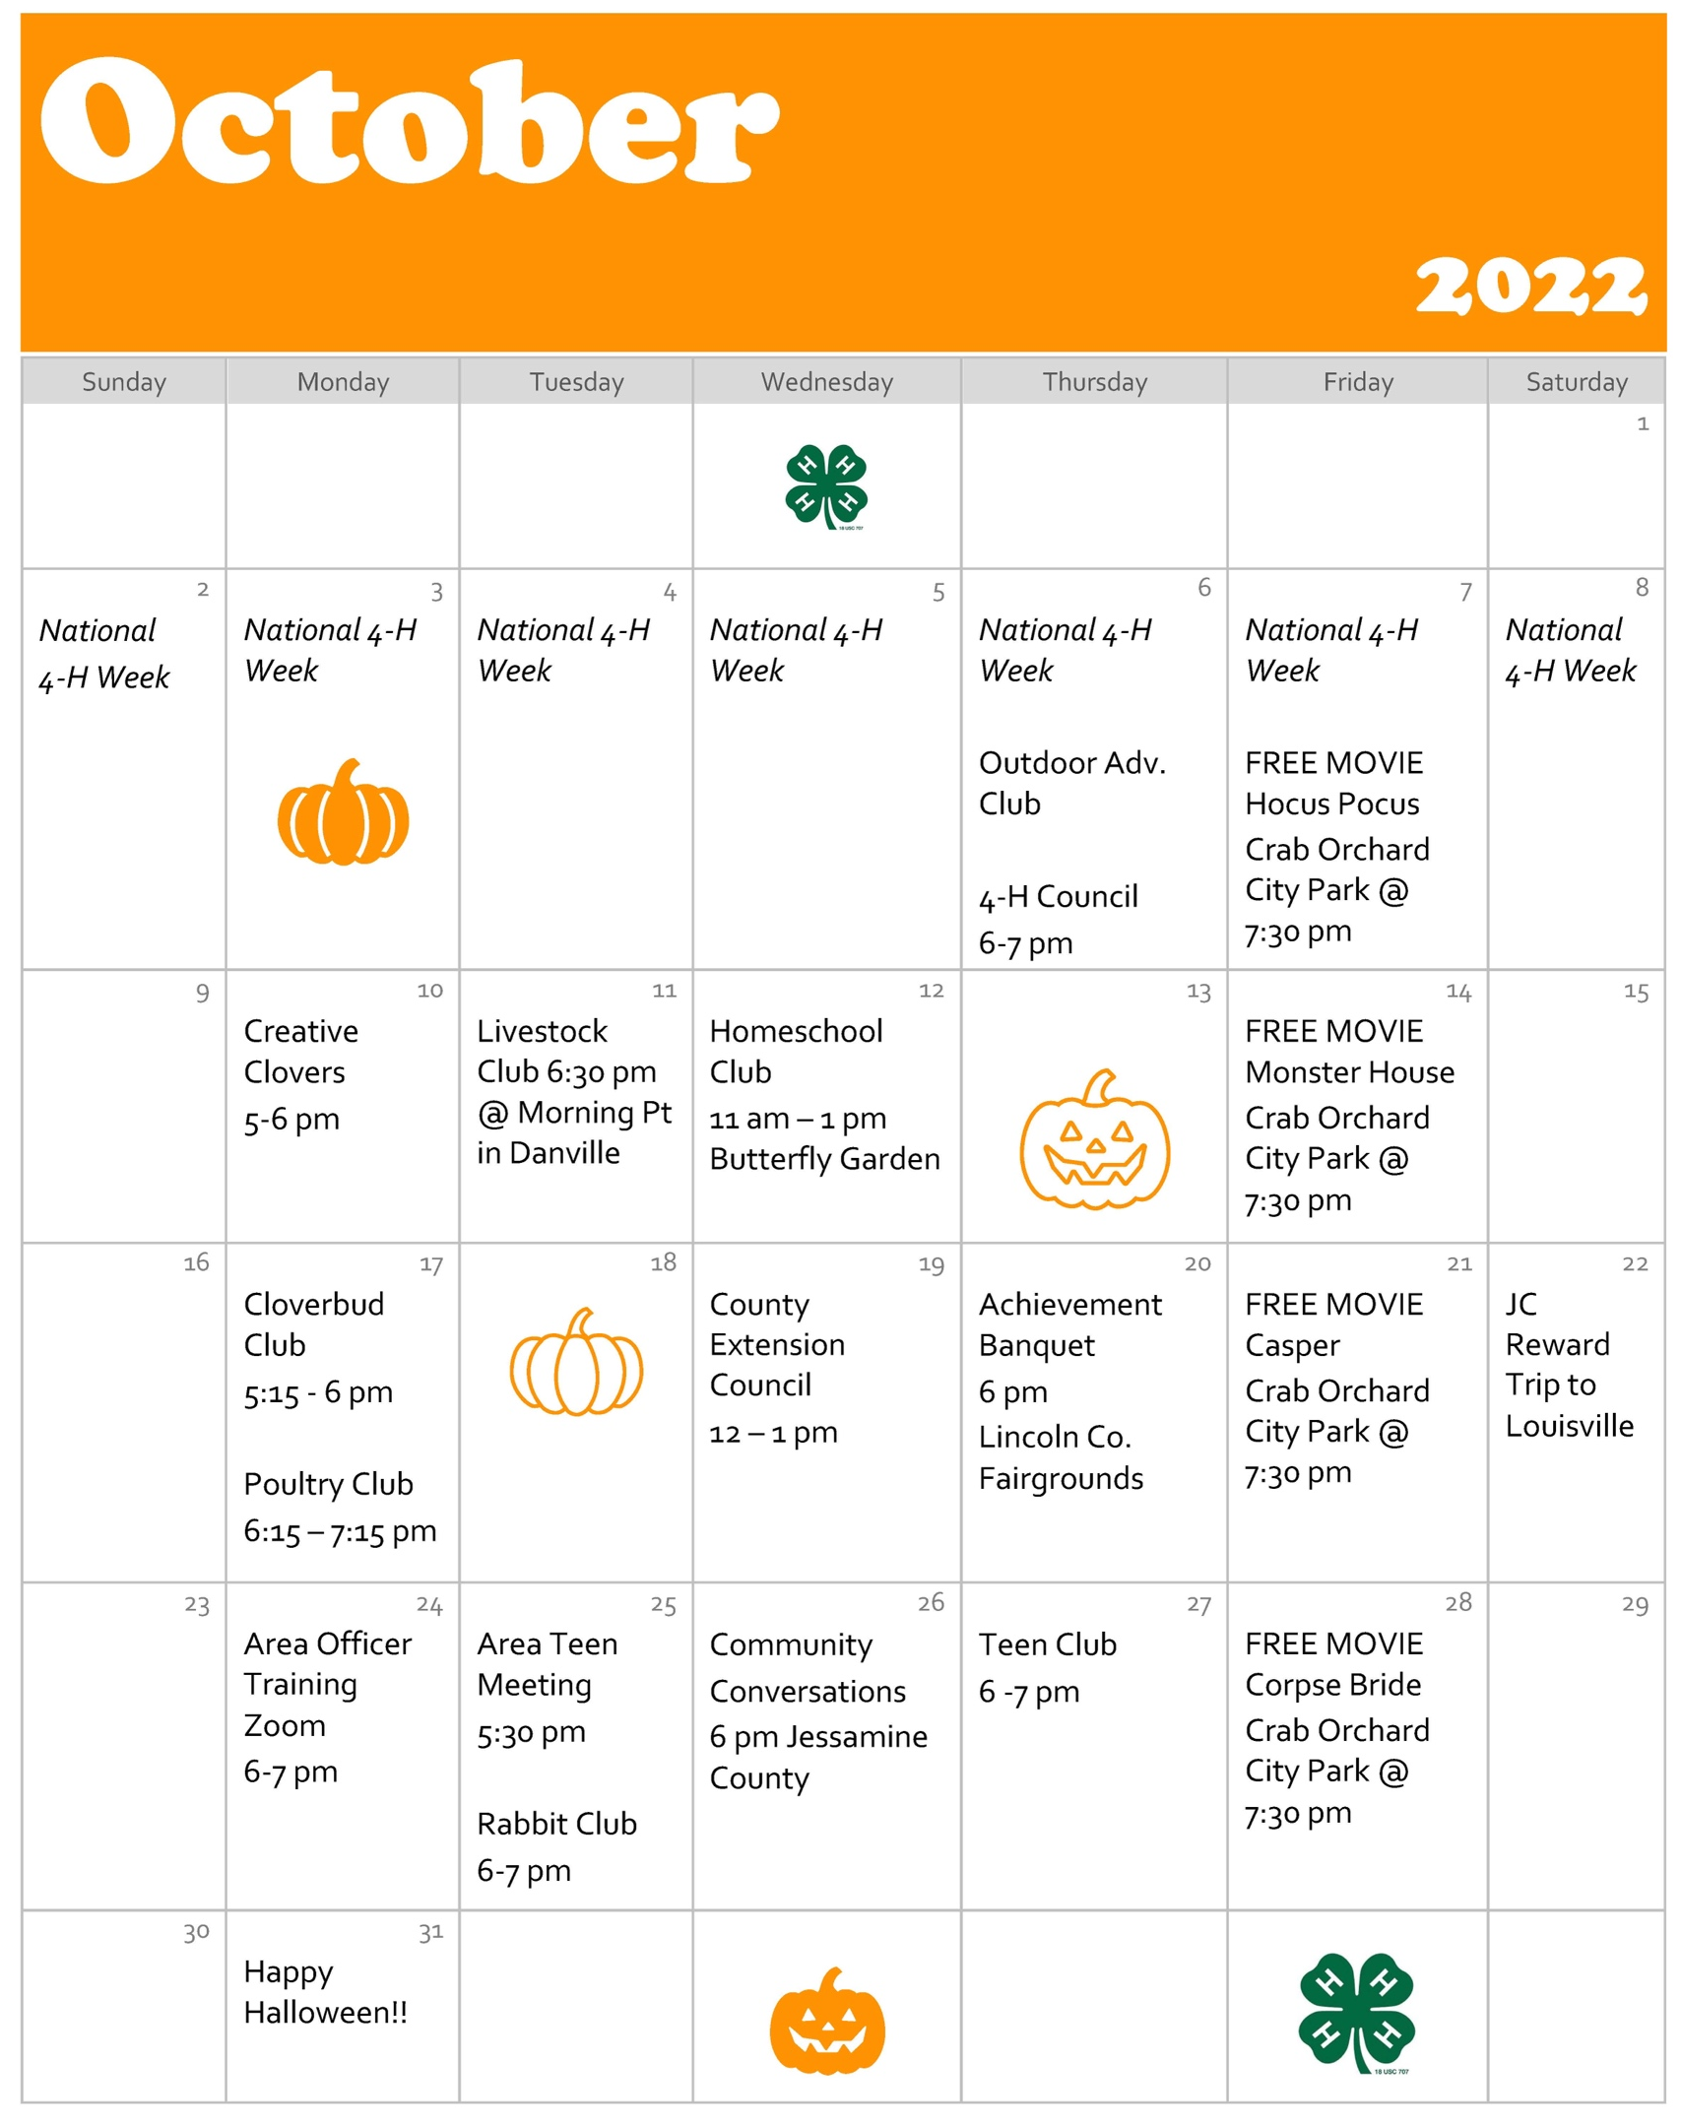

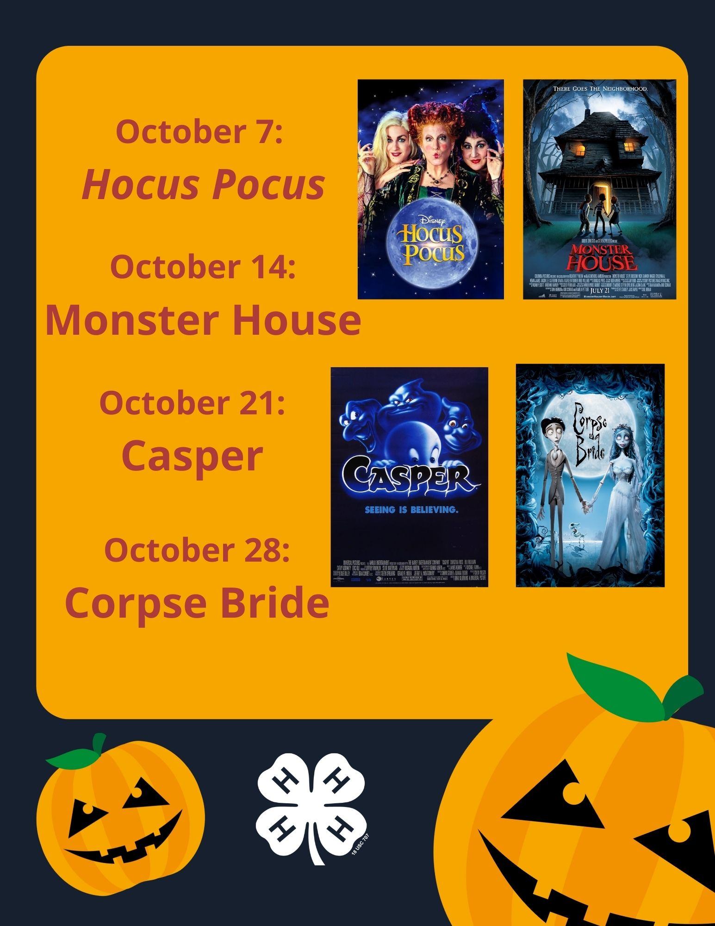
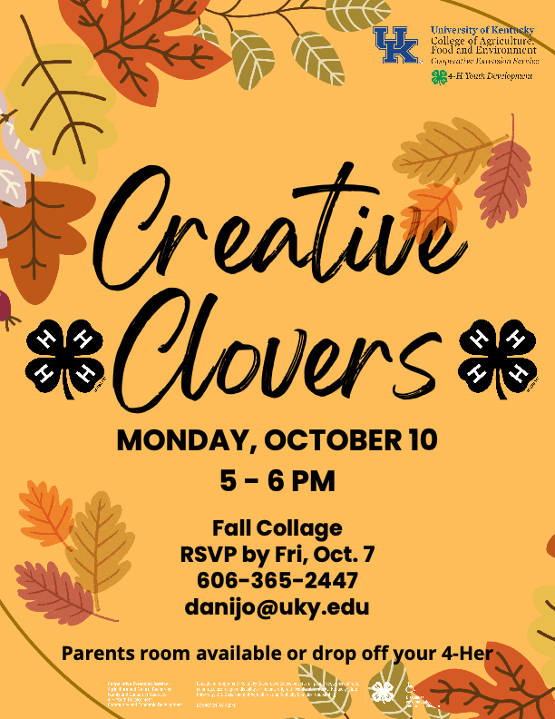



Join Lincoln County 4-H as we participate in the 2022 4-H Issues Conference at the JM Feltner 4-H Camp in London, Kentucky. This conference is scheduled for November 17 – 19, 2022 and is open to all youth currently enrolled in high school.
Teen participants will spend two nights and three days learning what it takes to tackle important issues in their local communities. Youth will discuss issues they care about the most, create a solution plan, and present their plans to a mock fiscal court.
There’s also plenty of time to meet teens from around the state, play games, dress up for the dance, and have a whole lot of fun. More information and applications will be available soon.
4-H Issues Conference

Achievement Program

The Kentucky 4-H Achievement Program helps young people learn how to set and achieve goals, while also rewarding ambitious and accomplished youth throughout the state.
In the Achievement Program, youth receive recognition and prizes for their accomplishments in 4-H. Youth can start accumulating points as soon as they start 4-H and begin earning recognition in the sixth grade.
4-Her’s earn points toward the completion of each of five non-competitive levels by participating in various leadership opportunities, projects, activities, and events. Competitive levels include bronze, silver, gold, and emerald. Gold winners receive a full scholarship to the Teen Conference and a scholarship to the National 4-H Congress in Atlanta, Georgia. Emerald winners receive a scholarship to attend the annual National 4-H Conference in Washington, D.C., and a $1,000 college scholarship.
For more information, or to obtain an electronic application on a flash drive, you may contact the Extension Office at 606-365-2447
Completed applications are due by 4:30 pm on Wednesday, November 23.

