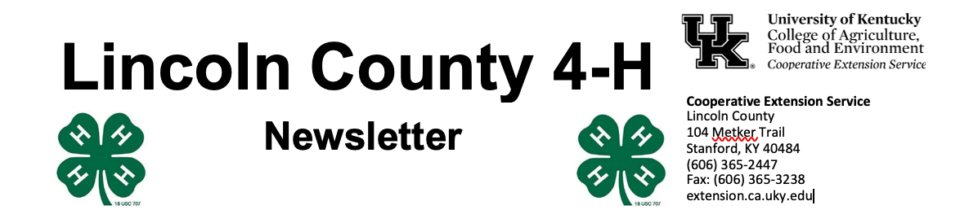
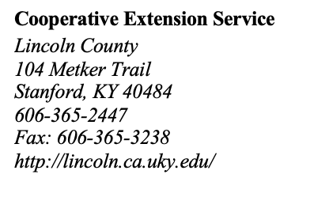
November 2022

4 - H Y O U T H D E V E L O P M E N T N E W S L E T T E R
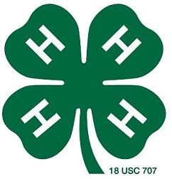



A chill is in the air and there are lots of things happening at the Extension Office! Included in this newsletter is information and a contract for the 2023 4-H Country Ham Contest. We have a fantastic couple of leaders that help with this program and would love to fill up our ham barn this January! Please let us know if you have questions.
Also, mark your calendars for our annual Breakfast & Shopping with Santa Event on Saturday, December 10 from 9 am – noon. Teen Club is also working on a holiday parade float, so look for us on December 3.
And it’s never too early to start working on your speech and/or demonstration. We’re trying something new this year and hosting both contests on the same night.
Our office is open Monday – Friday from 8 am – 4:30 pm and closed for lunch from 12- 1 pm. Please visit www.lincoln4h.org to check out all the most recent 4-H information.

Use your phone’s camera to enroll:


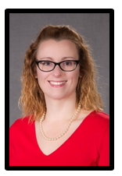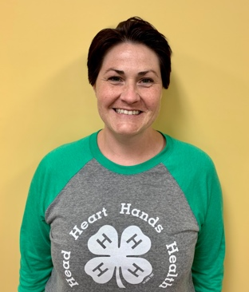
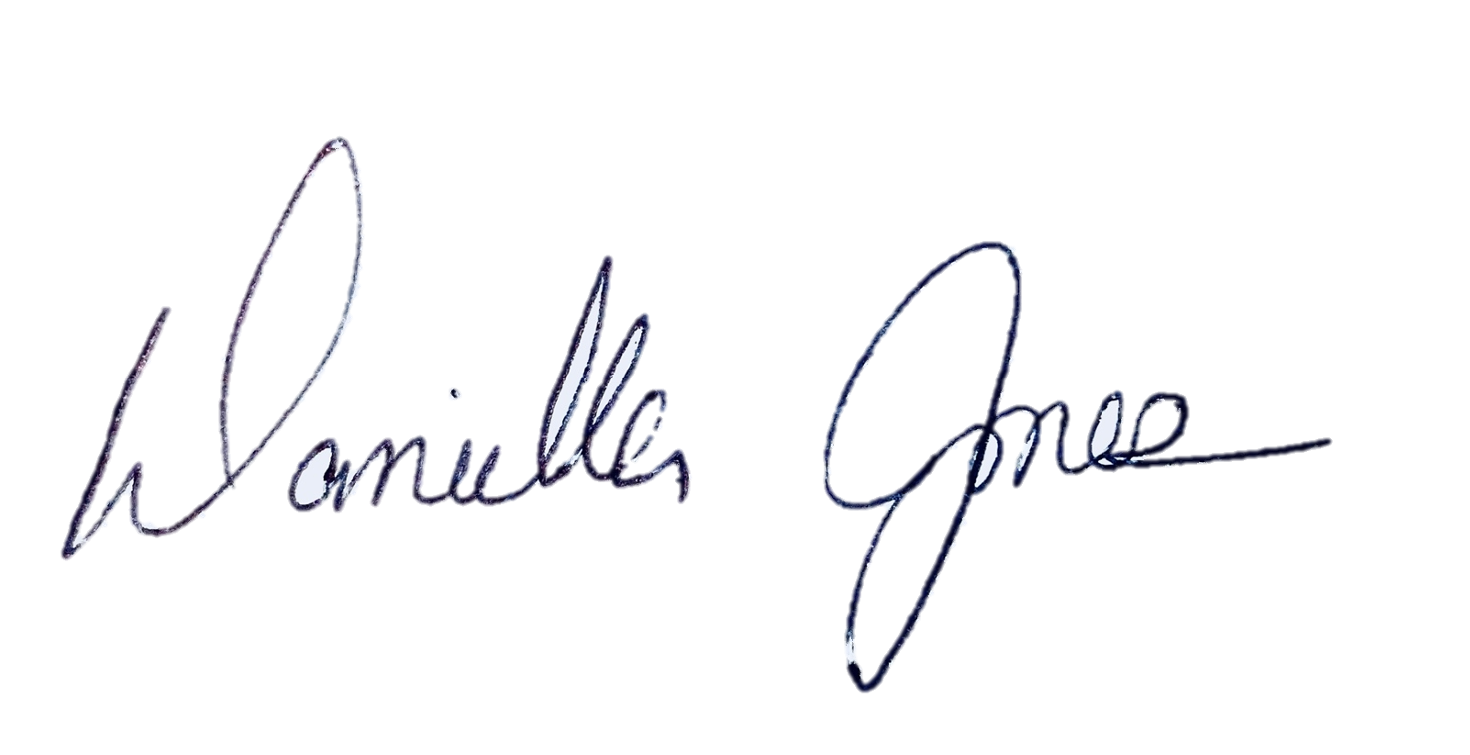
Dani Jones
Extension Program Assistant
606-365-2447
danijo@uky.edu

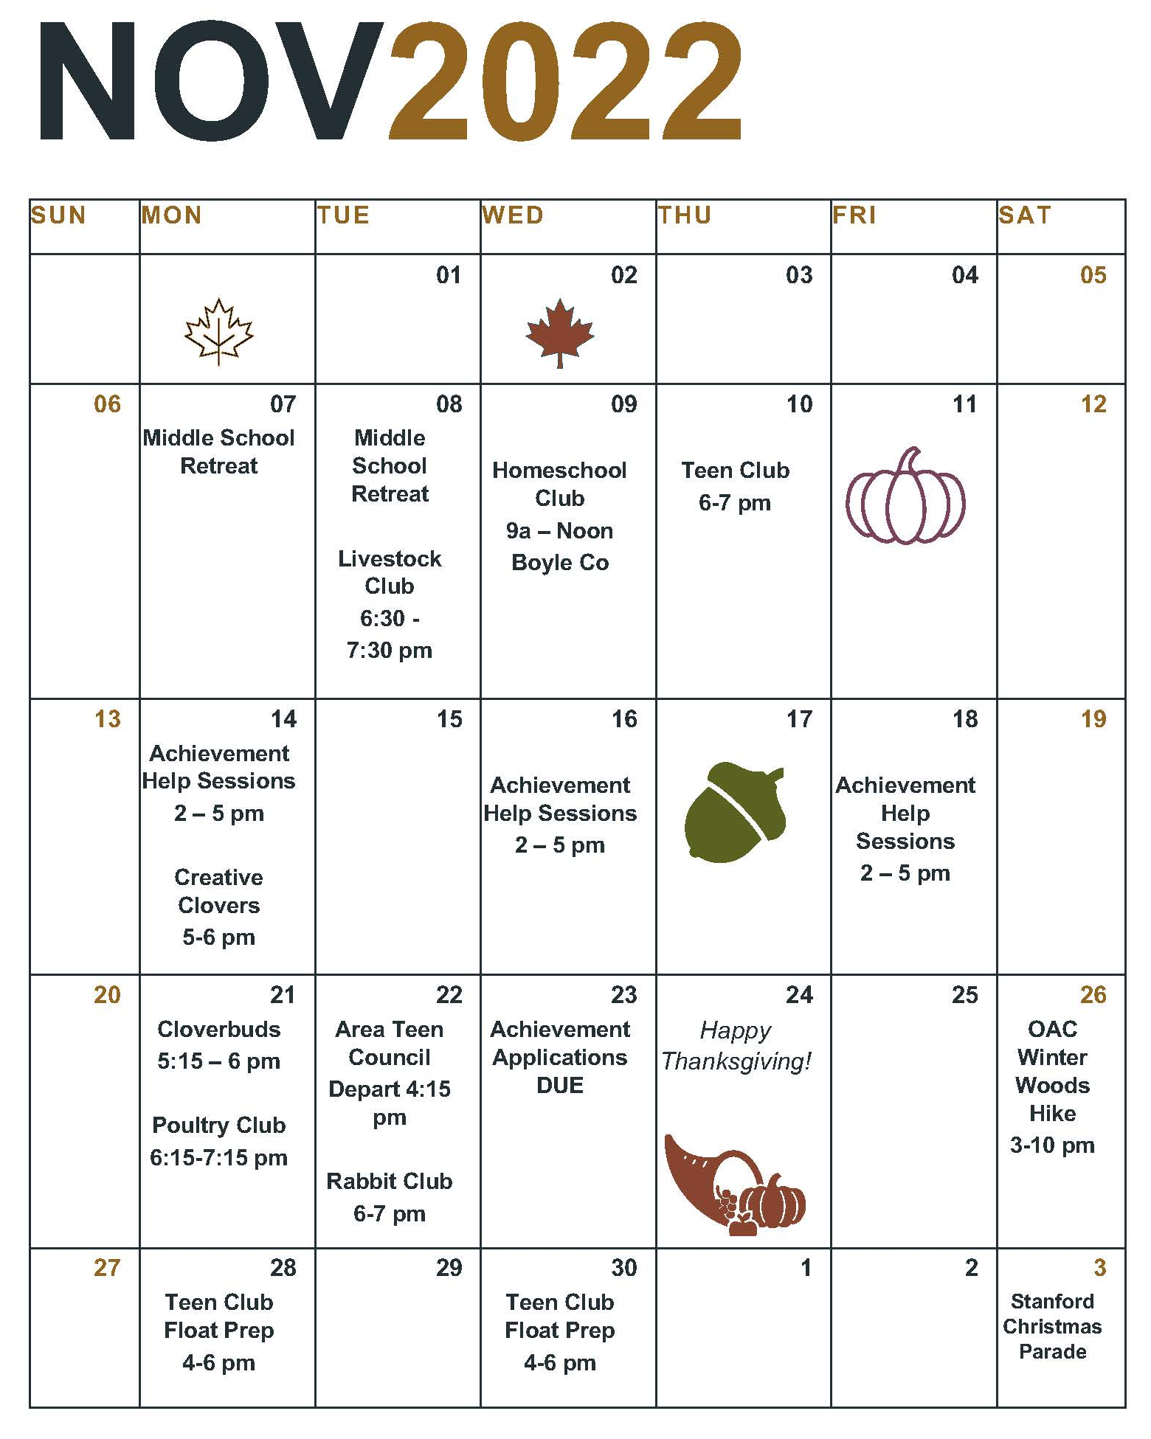

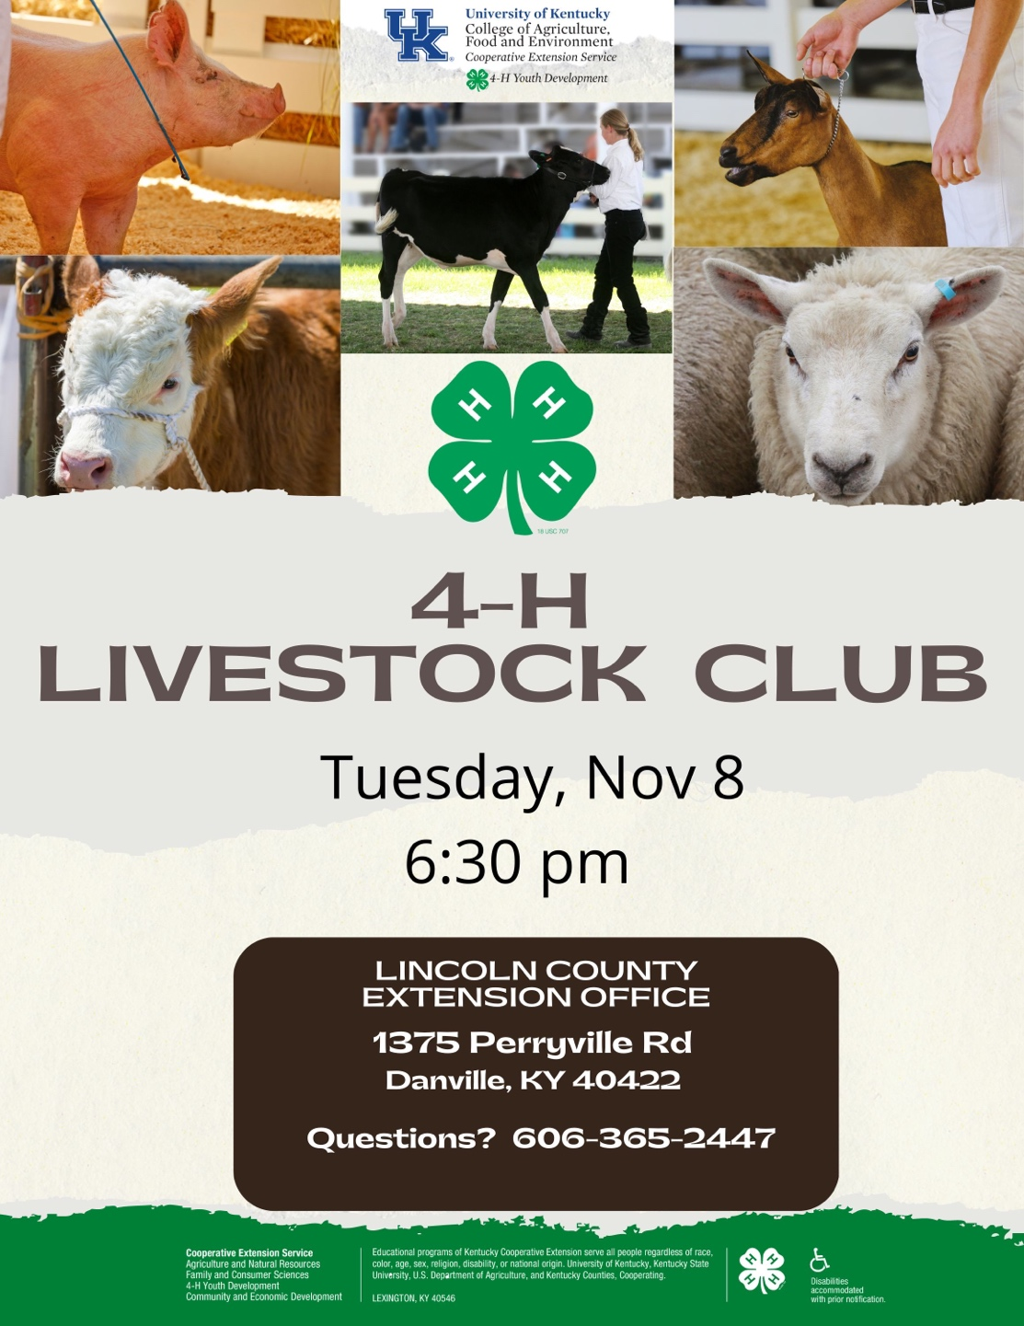

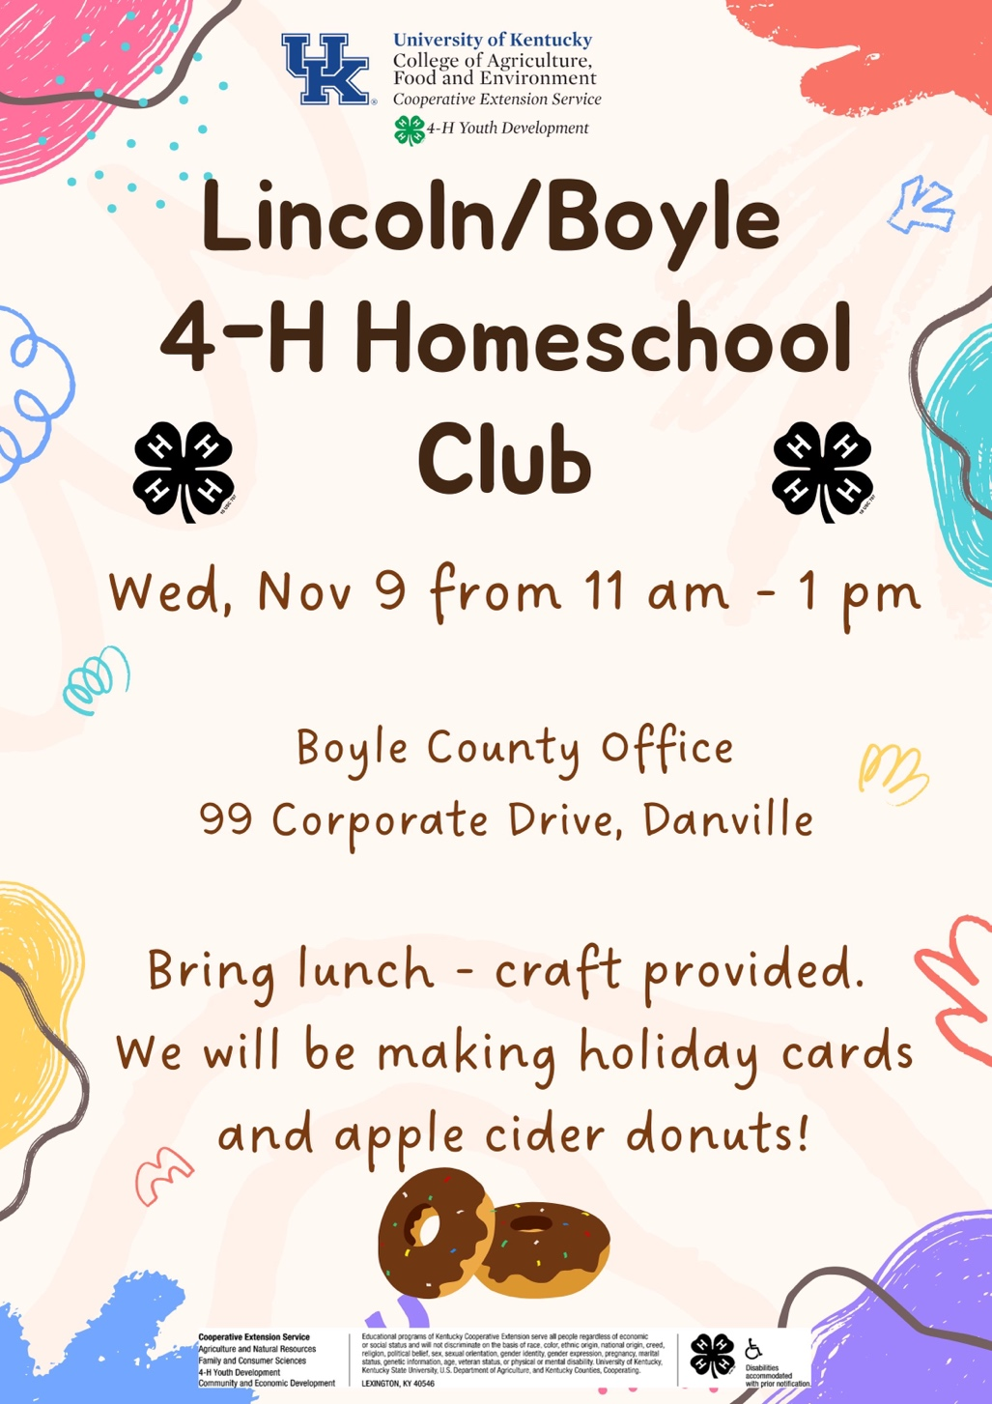

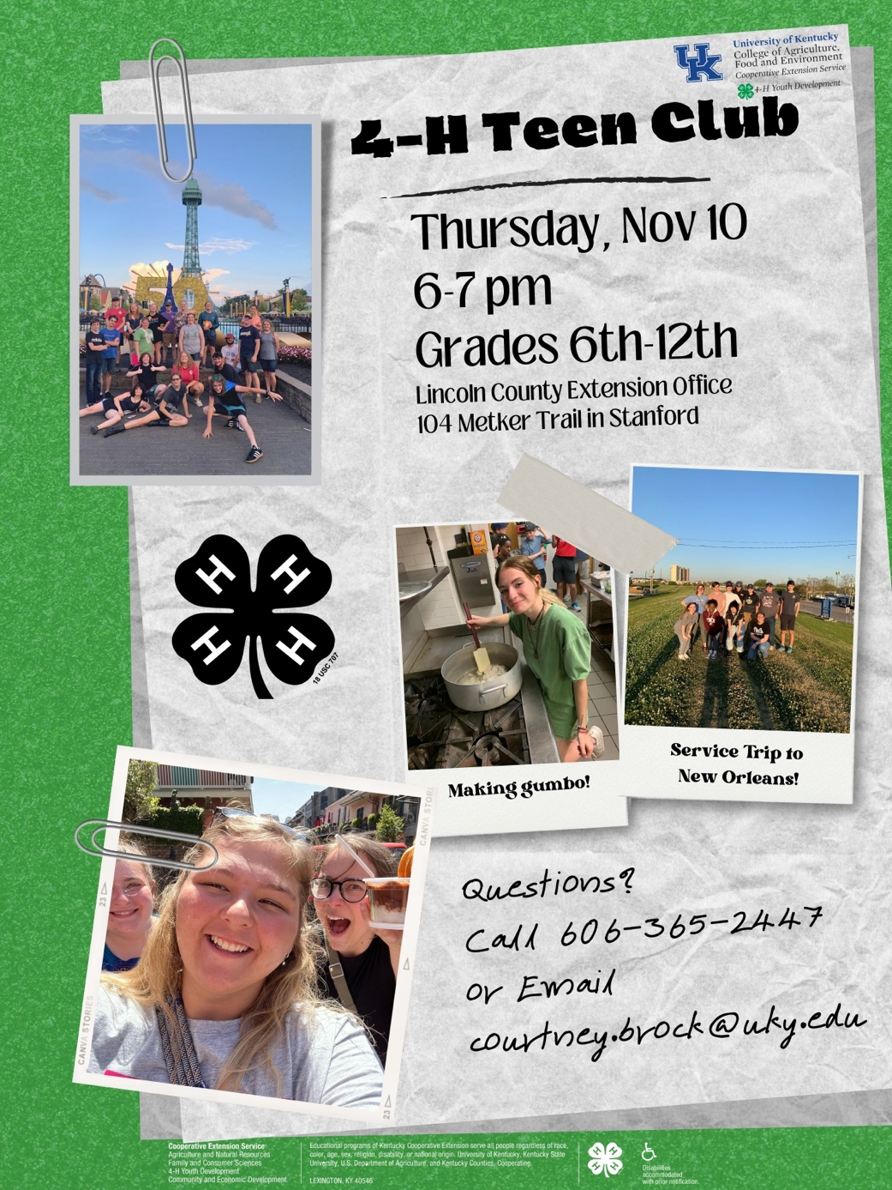

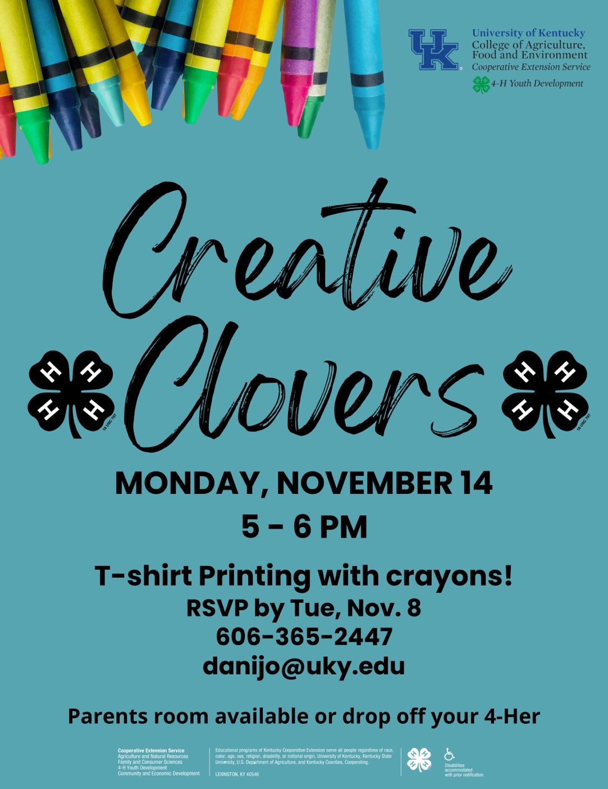
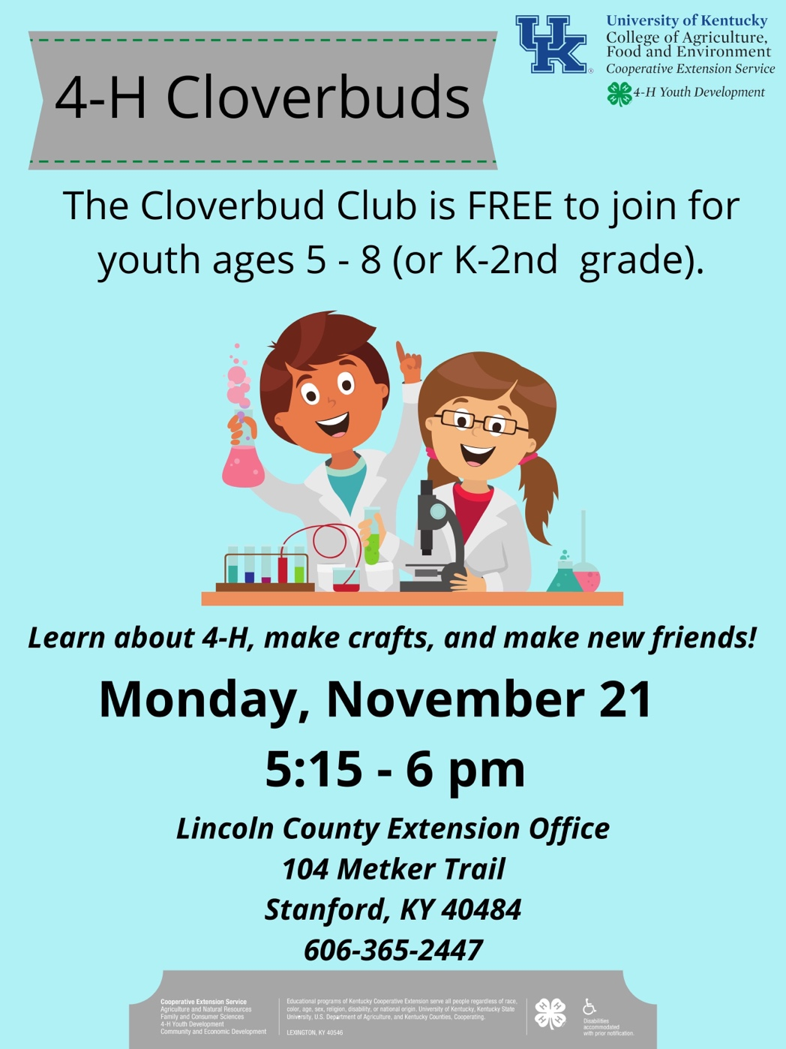

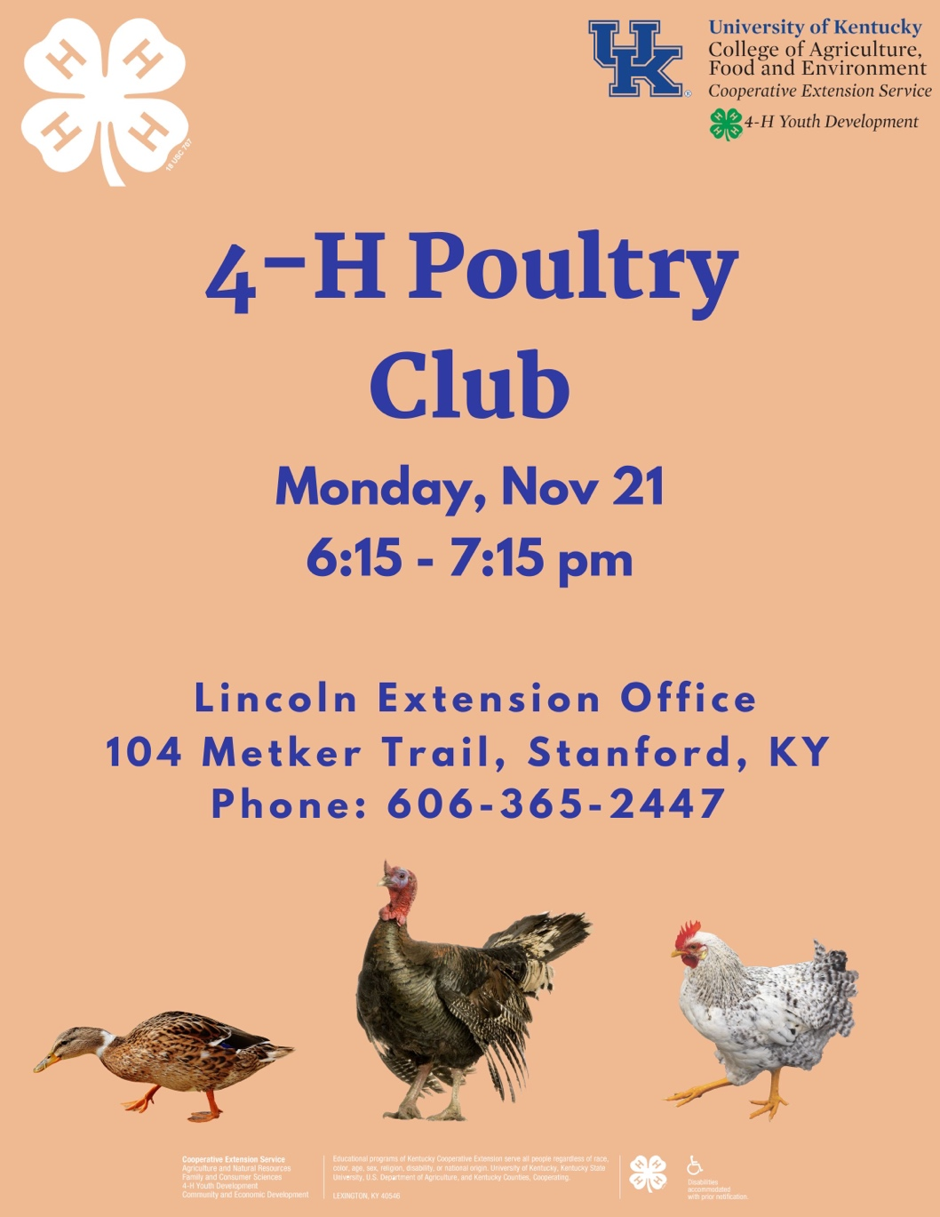
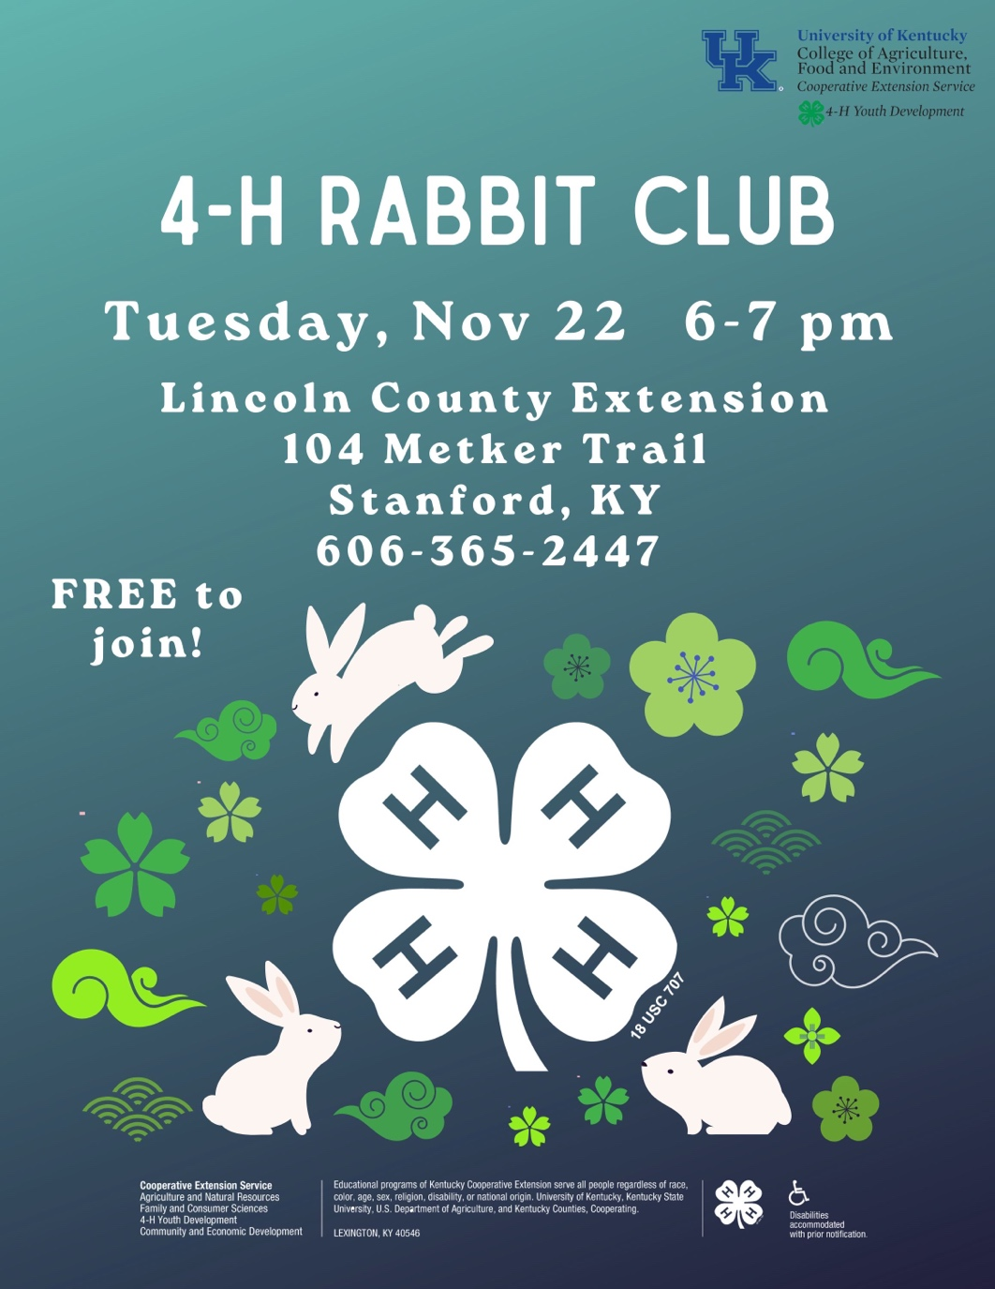


Gear up for 4-H Communications Contests!

The 4-H Speech and Demonstration Contest will be held Thursday, January 26, 2023, at the Lincoln County Extension Office. Registration starts at 5:30 p.m. and the contest begins at 6 p.m. Cloverbuds (ages 6-8) are welcome to participate but will not advance to district or state levels.
SPEECH CONTEST
Youth ages of 9-13 are in the junior division for and should prepare a 3 to 5-minute-long speech and may use notecards (but no visual aids, like posters). At the senior level, youth ages 14-18 must prepare a speech between 5 & 7 minutes in length. The event is also divided up among ten different age categories, depending on the participant’s age of January 1, 2023. All participants will receive $10 in 4-H Bucks, coupons that can be used towards any 4-H event registration costs, like 4-H camp. Each winner in their age category will receive an additional $15 in 4-H bucks and will go on to compete in the Area 4-H Talk Meet, which will be held later in the spring.
DEMONSTRATION CONTEST
An effective demonstration teaches others how to do something by showing while telling. At the end of a demonstration, you should have a finished product to show to your audience. Demonstration subjects should be interesting, fun, and suitable for an audience. Demonstrations should be between 10 and 15 minutes and must have posters or other visual aids. Participants are divided into junior (ages 9-13) and senior (14-18) levels, and then by topic (foods, arts, sewing, nature etc.). All participants will receive $10 in 4-H Bucks, and each winner will receive an additional $15 in and will go on to compete in the Area Demonstration Contest.

Achievement Program
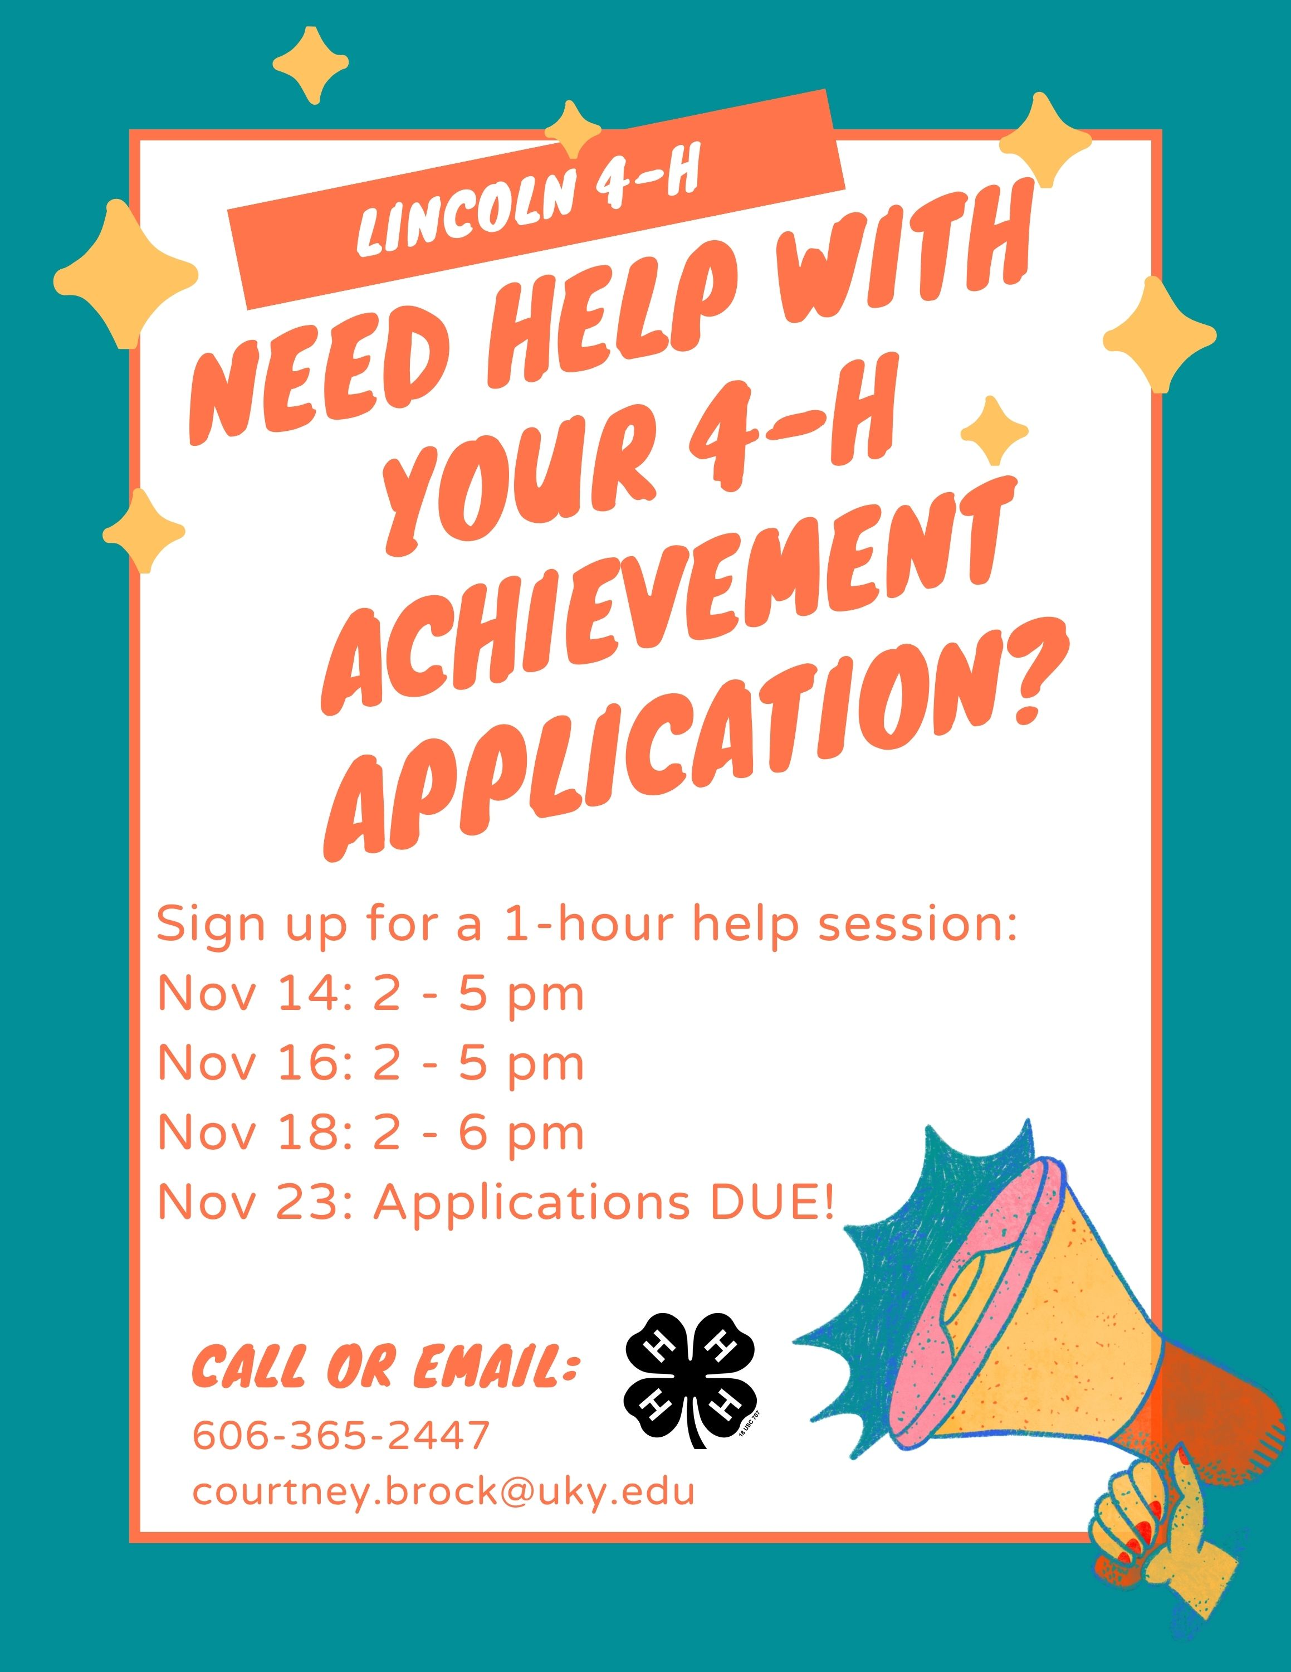

The Kentucky 4-H Achievement Program helps young people learn how to set and achieve goals, while also rewarding ambitious and accomplished youth.
In the Achievement Program, youth receive recognition and prizes for their accomplishments in 4-H. Youth can start accumulating points as soon as they start 4-H.
4-Her’s earn points toward the completion of each of five non-competitive levels by participating in various leadership opportunities, projects, activities, and events. Competitive levels include bronze, silver, gold, and emerald. Gold winners receive a full scholarship to Teen Conference and a scholarship to the National 4-H Congress in Atlanta, Georgia. Emerald winners receive a scholarship to attend the annual National 4-H Conference in Washington, D.C., and a $1,000 college scholarship.
For more information, or to obtain an application, you may contact the Extension Office at 606-365-2447
Completed applications are due by 4:30 pm on Wednesday, November 23.

