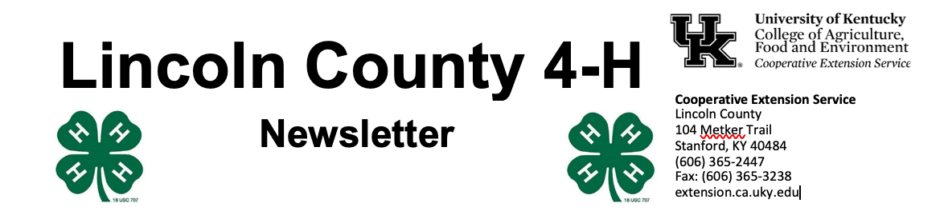
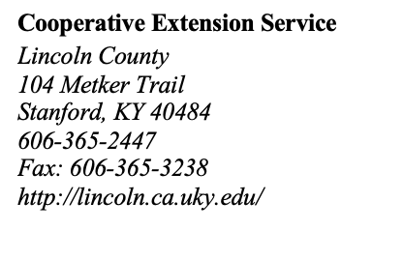
March 2023

4 - H Y O U T H D E V E L O P M E N T N E W S L E T T E R

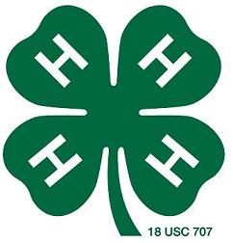

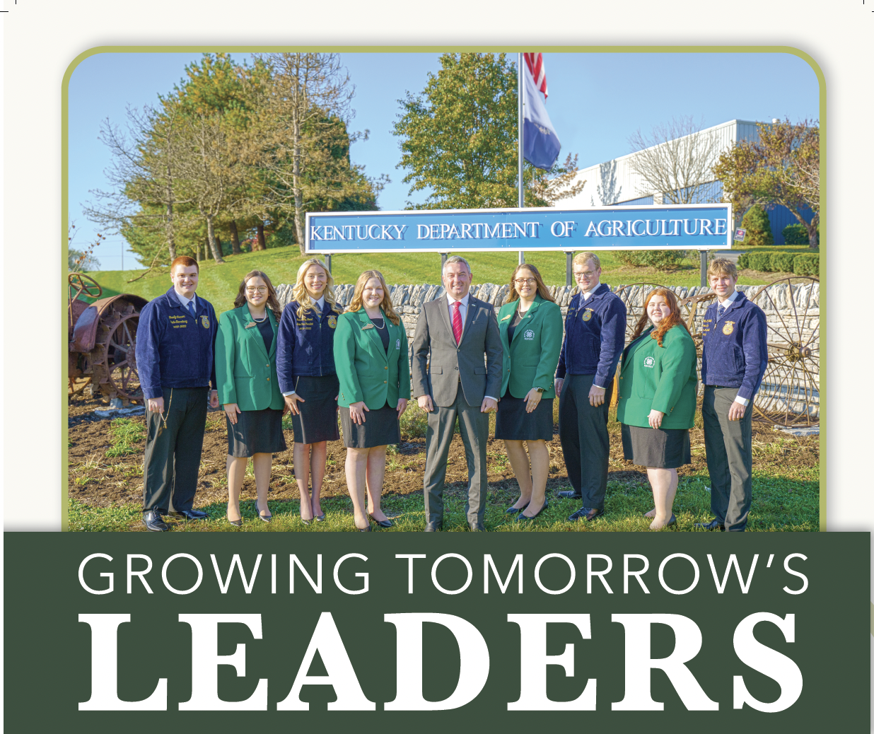


Believe it or not, applications for 4-H Camp 2023 are available now! Mark your calendar for July 17 - 21 and the theme this year is 4-H Time Warp. We have an early bird discount (and a bonus camp t-shirt!) available until the end of March, so be sure to get your applications in as soon as you can! A limited number of half scholarships are available
As you renew your ag farm tags this spring, please consider making the voluntary $10 donation. These funds are shared equally between 4-H, FFA, and the KY Proud Program and more than 2/3^{rds} of the money comes right back here to Lincoln County youth. In 2021, Lincoln County received more than $600 from our generous farmers. Your support of this outstanding program is greatly appreciated.
Please reach out with your camp questions or anything else you need information about. Our office is open Monday – Friday from 8 am – 4:30 pm and closed for lunch from 12- 1 pm. Please visit www.lincoln4h.org to check out all the most recent 4-H information.

Use your phone’s camera to enroll:



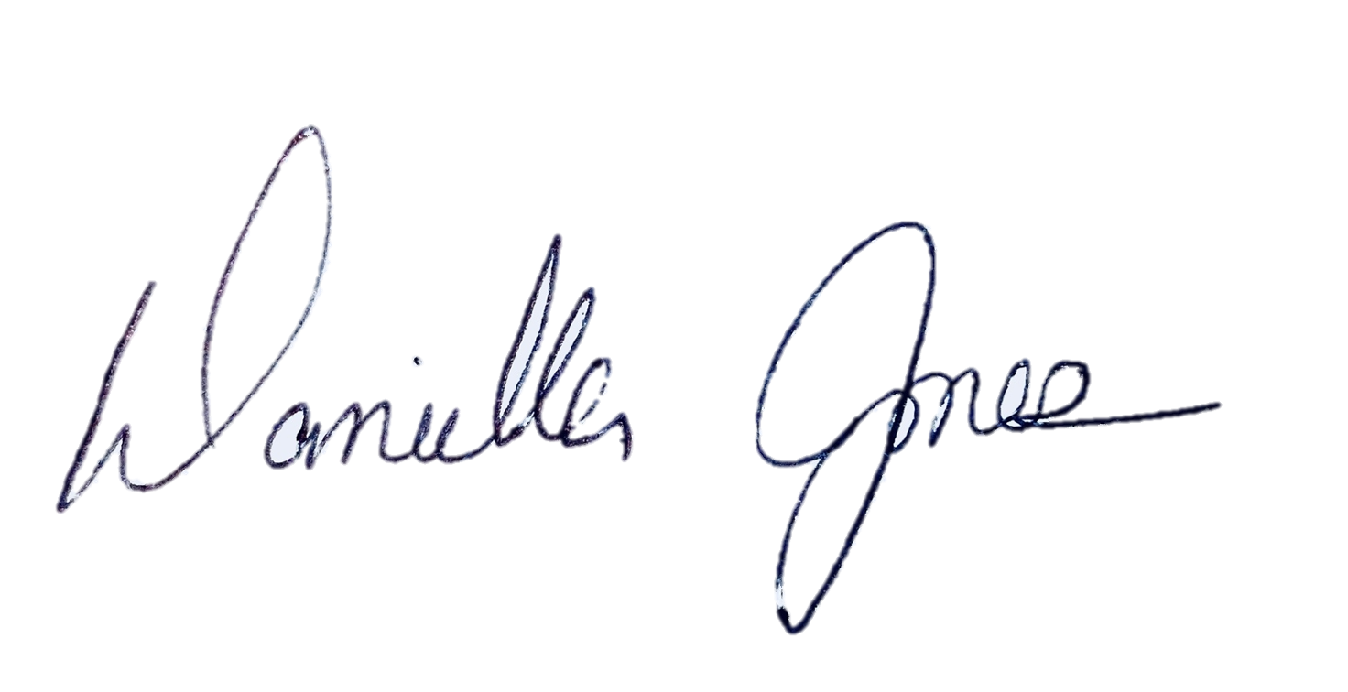
Dani Jones
Extension Program Assistant
606-365-2447
danijo@uky.edu

