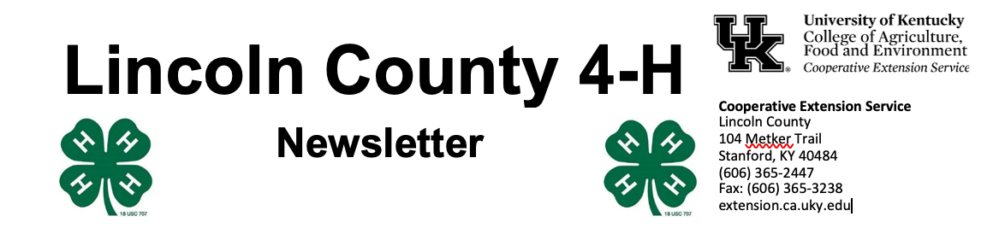
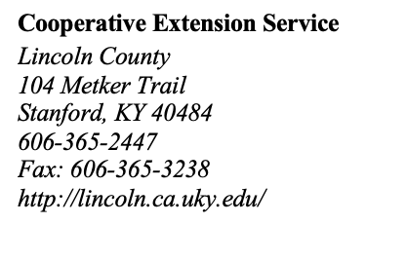
April-May 2023

4 - H Y O U T H D E V E L O P M E N T N E W S L E T T E R

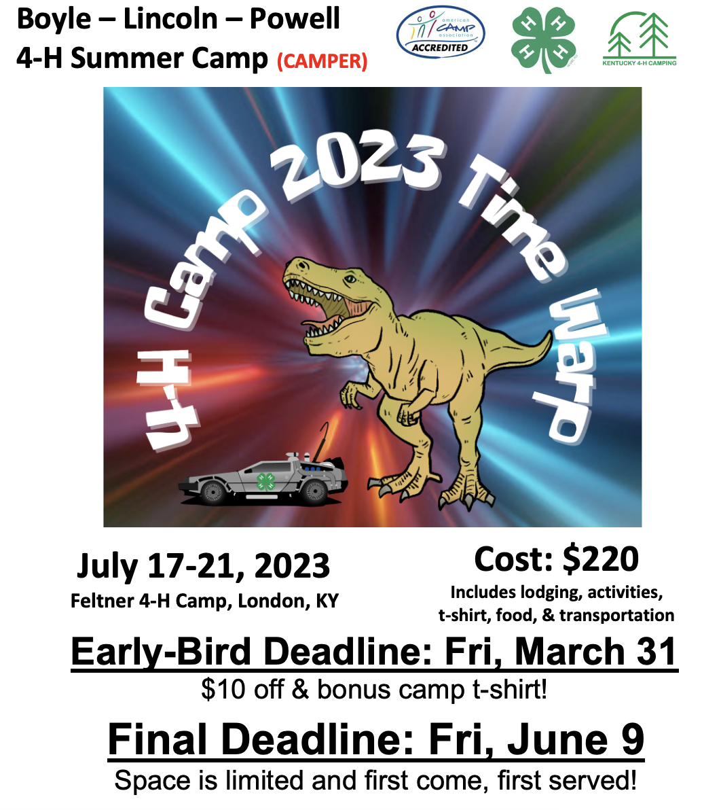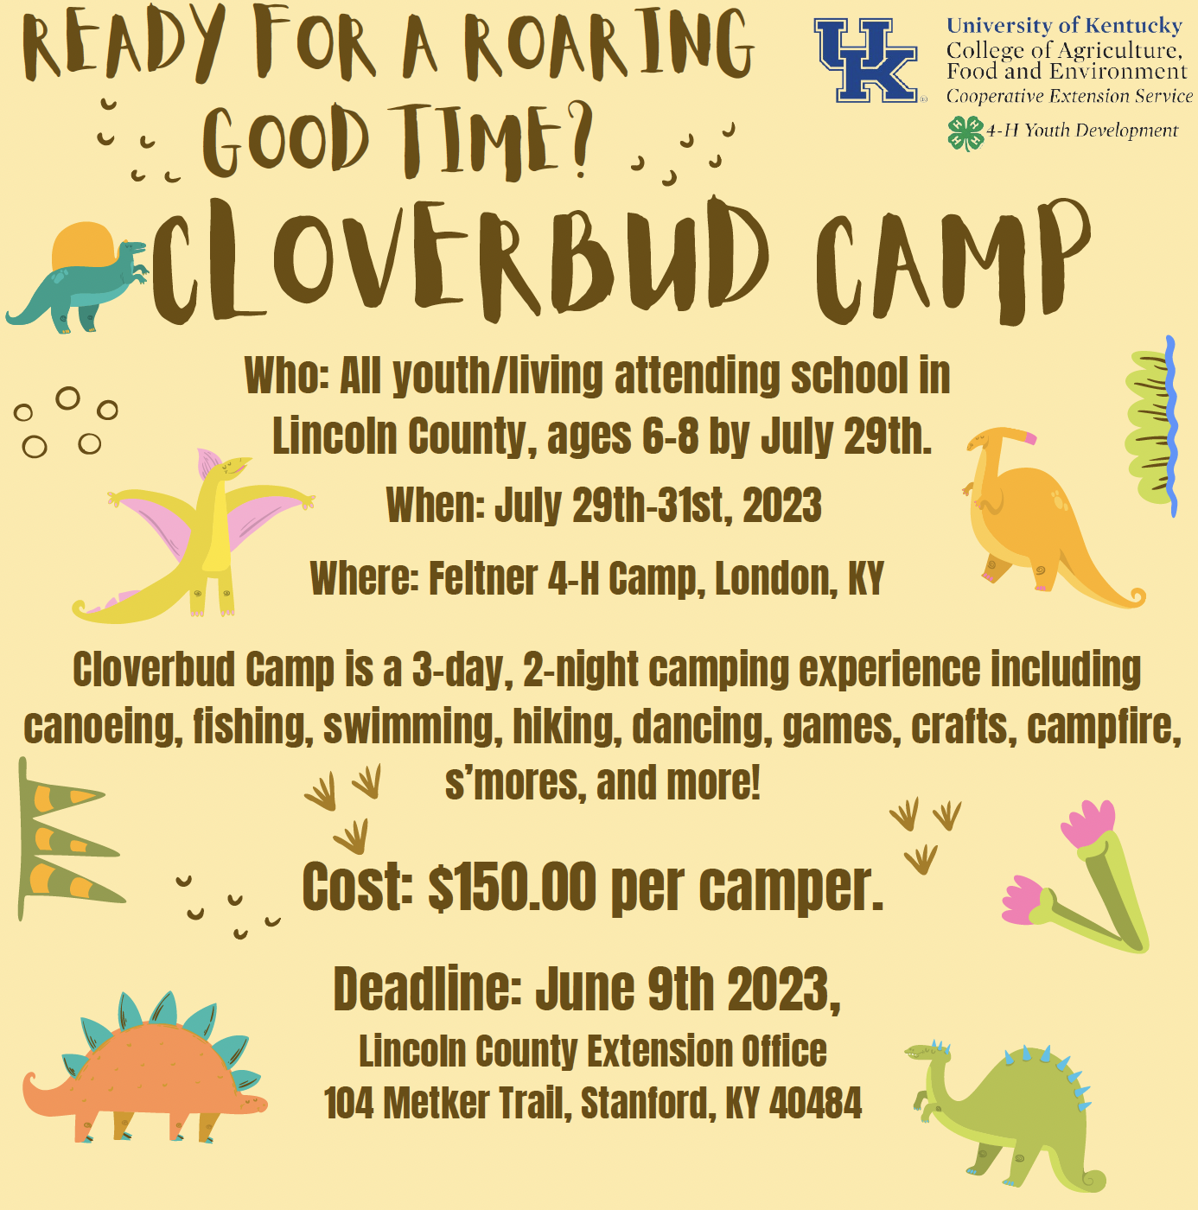
Spots are filling up quickly for 4-H Camp July 17-21, so please get your applications in as soon as possible! The 4-H camp scholarship deadline has been EXTENDED to Friday, April 28.
Please make note of the following:
- No 4-H Council meeting in April. Our next meeting will be Thursday, May 4 at 6 pm.
- Cloverbud Camp Applications are available now! This camp is for youth ages 6-8 and is scheduled for July 29-31. Cost is $150 for youth and adults. Deadline for registering is June 9.
- Registration is now available for 4-H Teen Conference (8th – 12th graders) June 13-16 on campus at UK. Contact Courtney or Dani for an application.
Our office is open Monday – Friday from 8 am – 4:30 pm and closed for lunch from 12- 1 pm. Please visit www.lincoln4h.org to check out all the most recent 4-H information Final deadline for all camp registration is Friday, May 20.


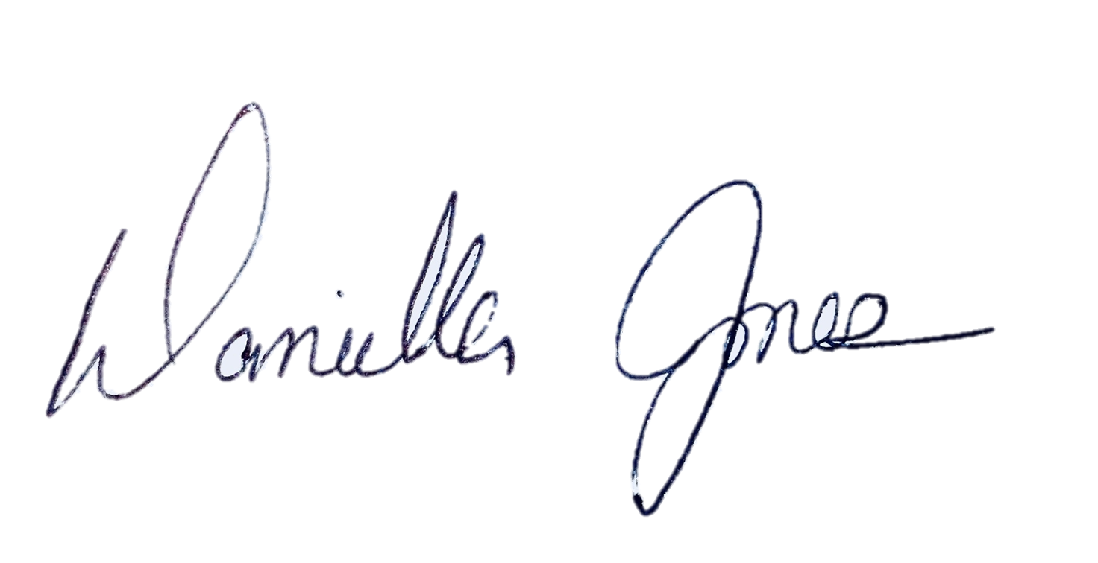
Dani Jones
Extension Program Assistant
606-365-2447
danijo@uky.edu


